 

## A Minor Project I Report on

IMPLEMENTATION OF AUTOMATIC

CURTAIN OPENER USING LDR SENSOR FOR

IMPAIRED PEOPLE

## Submitted by

**MADHAVAN K (927622BEE065)**

## SANGEETHA P (927622BEE093)

**SUDHARSHAN D S (927622BEE117)**



**DEPARTMENT OF ELECTRICAL AND ELECTRONICS ENGINEERING M.KUMARASAMY COLLEGE OF ENGINEERING**

(An Autonomous Institution Affiliated to Anna University, Chennai) THALAVAPALAYAM, KARUR-639113.

## DECEMBER 2023

M.KUMARASAMY COLLEGE OF ENGINEERING

(Autonomous Institution, Affiliated to Anna University, Chennai)

# BONAFIDE CERTIFICATE

Certified that this Report titled **“IMPLEMENTATION OF AUTOMATIC CURTAIN OPENER USING LDR SENSOR FOR IMPAIRED PEOPLE”** is the Bonafide work of **MADHAVAN.K(927622BEE065),SANGEETHA.P(927622BEE093)SUDHARSHAN.D.S(927622BEE117)**who carried out the work during the academic year (2023-2024) under my supervision. Certified further that to the best of my knowledge the work reported herein does not form part of any other project report.

**SIGNATURE SIGNATURE**

**SUPERVISOR** **HEAD OF THE DEPARTMENT**

Dr.S,Sathishkumar M.E., Ph.D, Dr.J.Uma M.E., Ph.D,

Associate Professor Professor & Head

Department of Electrical Department of Electrical

and Electronics Engineering and Electronics Engineering

M.Kumarasamy College of M.Kumarasamy College of

Engineering, Karur Engineering, Karur

Submitted for Minor Project I (18EEP201L) viva-voce Examination held at M..Kumarasamy College of Engineering, Karur-639113 on ………………..

## DECLARATION

We affirm that the Minor Project I report titled “**IMPLEMENTATION OF AUTOMATIC CURTAIN USING LDR SENSOR FOR IMPAIRED PEOPLE”** being submitted in partial fulfillment for the award of **Bachelor of Engineering in Electrical and Electronics Engineering** is the original work carried out by us.

|  |  |  |
| --- | --- | --- |
| **REG.NO** | **STUDENT NAME** | **SIGNATURE** |
| **927622BEE065** | **MADHAVAN K** | **------------------------** |
| **927622BEE093** | **SANGEETHA P** | **------------------------** |
| **927622BEE117** | **SUDHARSHAN D S** | **------------------------** |

### VISION AND MISSION OF THE INSTITUTION

**VISION**

* To emerge as a leader among the top institutions in the field of technical education

### MISSION

* Produce smart technocrats with empirical knowledge who can surmount the global Challenges.
* Create a diverse, fully engaged, learner - centric campus environment to provide Quality education to the students.
* Maintain mutually beneficial partnerships with our alumni, industry and Professional associations.

### DEPARTMENT OF ELECTRICAL AND ELECTRONICS ENGINEERING VISION

To produce smart and dynamic professionals with profound theoretical and practical knowledge comparable with the best in the field.

### MISSION

* Produce hi-tech professionals in the field of Electrical and Electronics Engineering by inculcating core knowledge.
* Produce highly competent professionals with thrust on research.
* Provide personalized training to the students for enriching their skills.

### PROGRAMME EDUCATIONAL OBJECTIVES (PEOs)

* **PEO1:** Graduates will have flourishing career in the core areas of Electrical Engineering and also allied disciplines.
* **PEO2:** Graduates will pursue higher studies and succeed in academic/research careers
* **PEO3:** Graduates will be a successful entrepreneur in creating jobs related to Electrical and Electronics Engineering /allied disciplines.
* **PEO4:** Graduates will practice ethics and have habit of continuous learning for their success in the chosen career.

**PROGRAMME OUTCOMES (POs)**

After the successful completion of the B.E. Electrical and Electronics Engineering degree program, the students will be able to:

**PO1: Engineering Knowledge:** Apply the knowledge of mathematics, science, engineering fundamentals, and an engineering specialization to the solution of complex engineering problems.

**PO2: Problem Analysis:** Identify, formulate, review research literature, and analyze complex engineering problems reaching substantiated conclusions using first principles of mathematics, natural sciences, and engineering sciences.

**PO3: Design/Development of solutions:**

Design solutions for Complex engineering problems and design system components or processes that meet the specified needs with appropriate consideration for the public health and safety,and the cultural, societal and environmental considerations.

**PO4: Conduct Investigations of complex problems:** Use research-based knowledge and research methods including design of experiments, analysis and interpretation of data, and synthesis of the information to provide valid conclusions.

**PO5: Modern Tool Usage:** Create, select, and apply appropriate techniques, resources, and modern engineering and IT tools including prediction and modeling to complex engineering activities with an understanding of the limitations.

**PO6: The Engineer and Society:** Apply reasoning in formed by the contextual knowledge to assess societal, health, safety, legal and cultural issues and the consequent responsibilities relevant to the professional engineering practice.

**PO7: Environment and Sustainability:** Understand the impact of the professional engineering solutions in societal and environmental contexts, and demonstrate the knowledge of, and need for sustainable development.

**PO8: Ethics:** Apply ethical principles and commit to professional ethics and responsibilities and norms of the engineering practice

**PO9: Individual and Team work:** Function effectively as an individual, and as a member or leader in diverse teams, and in multi-disciplinary settings.

**PO10: Communication:** Communicate effectively on complex engineering activities with the engineering community and with society at large, such as, being able to comprehend and write effective reports and design documentation, make effective presentations, and give and receive clear instructions.

**PO11: Project Management and Finance:** Demonstrate knowledge and understanding of the engineering and management principles and apply these to one’s own work, as a member and leader in a team, to manage projects and in multi-disciplinary environments.

**PO12: Life-long learning:** Recognize the need for, and have the preparation and ability to engage in independent and life-long learning in the broadest context of technological change.

### PROGRAM SPECIFIC OUTCOMES (PSOs)

The following are the Program Specific Outcomes of Engineering Students:

* **PSO1:** Apply the basic concepts of mathematics and science to analyze and design circuits, controls, Electrical machines and drives to solve complex problems.
* **PSO2:** Apply relevant models, resources and emerging tools and techniques to provide solutions to power and energy related issues & challenges.
* **PSO3:** Design, Develop and implement methods and concepts to facilitate solutions for electrical and electronics engineering related real world problems.

|  |  |
| --- | --- |
| **Abstract (Key Words)** | **Mapping of POs and PSOs** |
| LDR Sensor, Battery,555 Timer IC, Two channel Relay Module,  DC Motor | PO1, PO2, PO3, PO4, PO5, PO6, PO7, PO8, PO9, PO11, PSO1, PSO2,PSO3 |

## [ACKNOWLEDGEMENT](https://www.google.com/search?rlz=1C1CHBD_enIN820IN820&q=ACKNOWLEDGEMENT&spell=1&sa=X&ved=0ahUKEwj99az1_ZXhAhVN63MBHRVODE4QkeECCCkoAA&cshid=1553265789884876)

Our sincere thanks to **Thiru.M.Kumarasamy, Chairman and Dr.K.Ramakrishnan B.E, Secretary** of **M.Kumarasamy College of Engineering** for providing extra ordinary infrastructure, which helped us to complete the Minor project in time.

It is a great privilege for us to express our gratitude to our esteemed **Principal Dr.B.S.Murugan M.Tech., Ph.D,** for providing us right ambiance for carrying out the project work.

We would like to thank our **Head of the Department Dr.J.Uma M.E., Ph.D, Department of Electrical and Electronics Engineering,** for their unwavering moral support throughout the evolution of the project.

We would like to express my deep gratitude to our Minor Project Guide **Dr.S.Sathishkumar M.E., Ph.D, Associate Professor, Department of Electrical and Electronics Engineering,** for his constant encouragement, kind co-operation, valuable suggestions and support rendered in making our project a success.

We offer our whole hearted thanks to our Minor project coordinator **Dr.B.Rajeshumar M.E., Ph.D, Assistant Professor, Department of Electrical and Electronics Engineering,** for his constant encouragement, kind co-operation and valuable suggestions for making our project a success.

We glad to thank all the **Faculty Members** of **Department of Electrical and Electronics Engineering** for extending a warm helping hand and valuable suggestions throughout the project.

Words are boundless to thank **Our Parents and Friends** for their constant encouragement to complete this Minor project successfully.

**TABLE OF CONTENTS**

|  |  |  |
| --- | --- | --- |
| CHAPTER NO | CONTENTS | PAGE NO |
|  | **ABSTRACT** | xi |
|  | **LIST OF FIGURES**  **LIST OF TABLES** | **ⅸ**  **ⅹ** |
|  | **SURVEY FORM** | **1** |
| 1 | **SURVEY FORM ANALYSIS**  1.1 Name and Address of the Community  1.2 Problem Identification  1.3 Proposed Solution | **4**  **4**  **4** |
| 2 | **LITRATURE REVIEW**  2.1 Smart Home System with Automatic Curtain Opener  2.2 IOT-based Curtain Control System  2.3 Voice-Activated Curtain Opener  2.4 Gesture-Controlled Smart Curtains  2.5Machine Learning Adaptive Curtain System | **5**  **5**  **5**  **5**  **6** |
| 3 | **PROPOSED METHODOLOGY**  3.1 Block Diagram  3.2 Description  3.3 Cost Estimation | **7**  **8**  **12** |
| 4 | **FUTURE SCOPE AND ITS IMPLEMENTATION PLAN** | **13** |
| 5 | **REFERENCES** | **14** |

**LIST OF FIGURES**

|  |  |  |
| --- | --- | --- |
| FIGURE NO | TITLE | PAGE NO |
| 3.1 | Block Diagram of Automatic Curtain Opener Using  LDR Sensor | **7** |
| 3.2  3.3 | Pin Diagram 555 TIMER IC  Light Dependent Resistor(LDR) | **9**  **11** |

**LIST OF TABLES**

|  |  |  |
| --- | --- | --- |
| TABLE NO | TITLE | PAGE NO |
| 3.3 | Cost Estimation | **12** |

**ABSTRACT**

This project introduces an innovative automatic curtain opener system designed to enhance convenience and energy efficiency in residential and commercial spaces. the system detects ambient light levels, user preferences, and environmental conditions to autonomously open or close curtains. Integrated with a user-friendly interface, it provides manual control options and can be seamlessly integrated into smart home ecosystems. The automated functionality aims to optimize natural light utilization, promote energy conservation, and elevate the overall comfort and modernity of living spaces. Additionally, the automatic curtain opener system incorporates machine learning algorithms to adapt to user routines, learning patterns of curtain usage over time. This adaptive feature ensures a personalized experience, anticipating user preferences and creating a more intuitive and efficient curtain control system. The project presents the development and implementation of a system designed to enhance the convenience, energy efficiency, and comfort of residential and commercial spaces. The LDR sensor enabling the system to detect changes in natural light levels. Based on this real-time data, the curtains or blinds are autonomously opened or closed, ensuring optimal lighting conditions. a novel solution that not only aligns with the demands of modern living but also contributes to a more sustainable and user-friendly environment. Based on the lighting condition curtain will move automatically Smart curtains with sensors can detect changes in ambient light, adjusting themselves accordingly. This can help to save energy by minimizing the need of artificial lighting and heating/cooling systems Smart curtains can be integrated to open and close the curtain without physical effort. This enhances accessibility and independence for members of the community with disabilities. It does the task of folding unfolding of the curtain as per the light intensity outside the window. It is an automatic process, and the light intensity is sensed by LDR in the circuit. In this operation using the DC motor for the curtain folding and unfolding.

**Keywords**: LDR Sensor, Battery, 555 Timer IC, Two channel Relay Module, DC Motor

**SAMPLE PHOTOS**

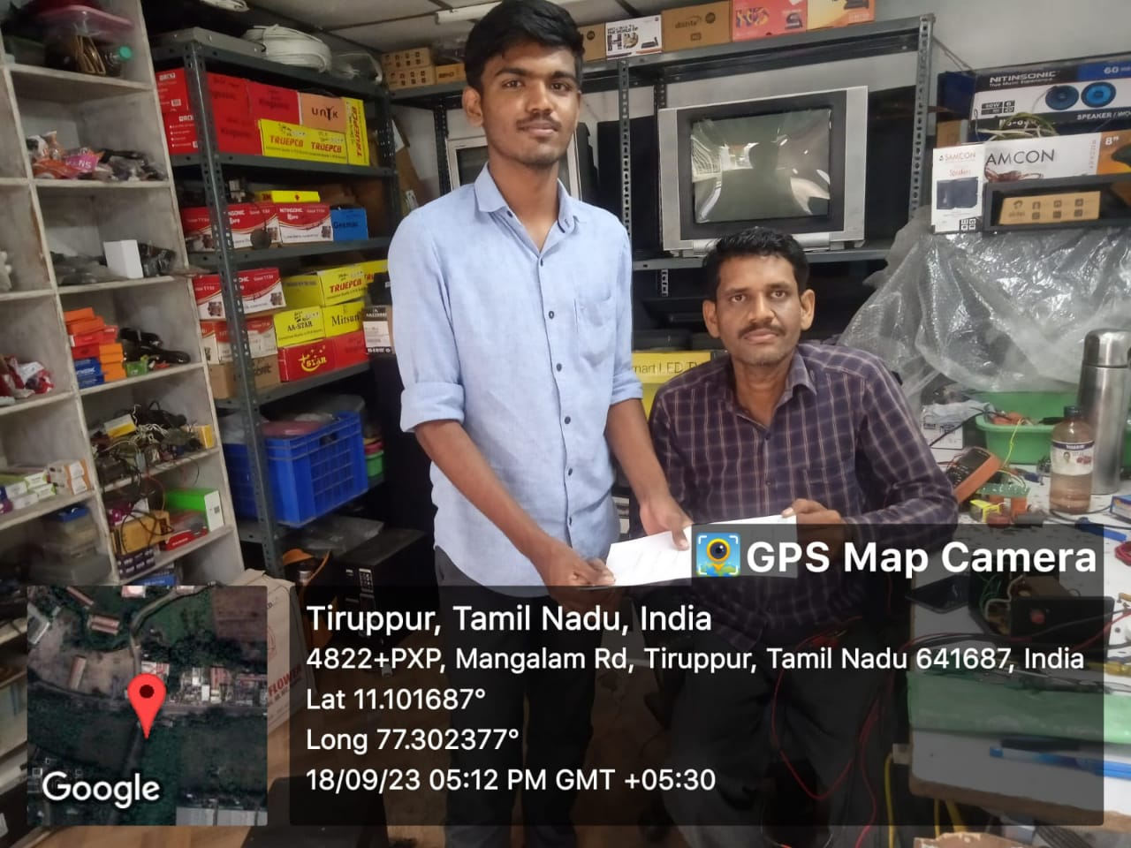

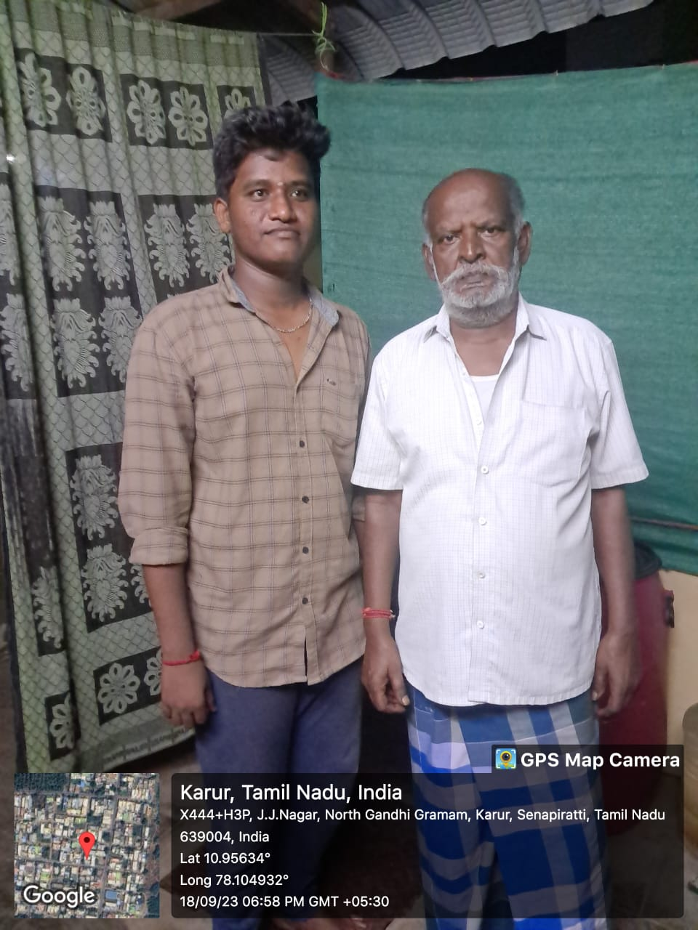

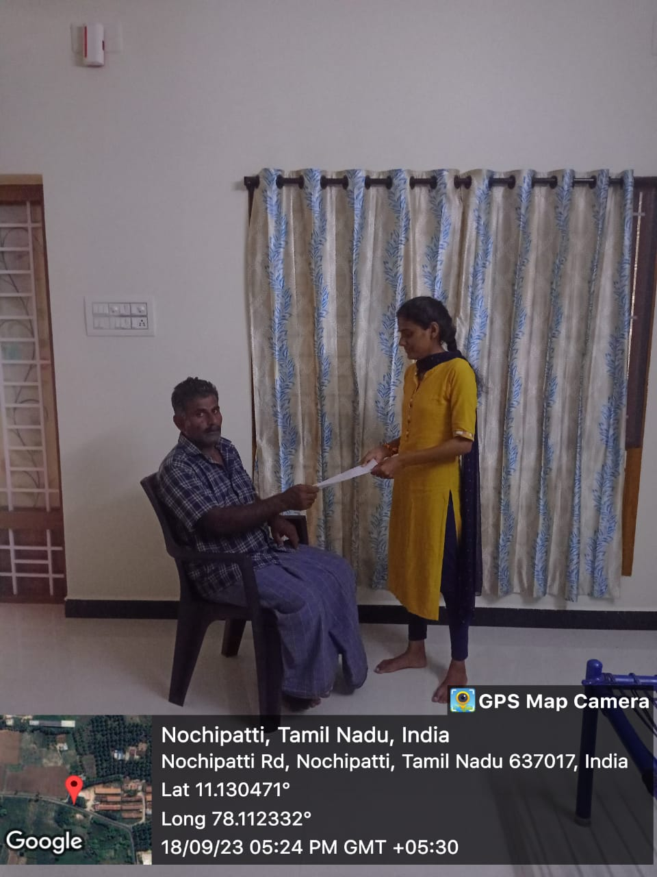

**CHAPTER 1**

**SURVEY FORM ANALYSIS**

**1.1 NAME AND ADDRESS OF THE COMMUNITY:**

1. **NAME:** P. Govindaraj

**ADDRESS:** 1/141, Laxmi Nagar, Chinnandipalayam, Tiruppur-641687.

1. **NAME:** K. Alagappan

**ADDRESS:** JJ Nagar, EB Colony, Gandhigrammam, Karur-639005.

1. **NAME:** K. Sekar

**ADDRESS:** Nochipatti, Namakkal-637017.

1. **NAME:** N. Natarajan

**ADDRESS:**1/14, Upputhottam, Mangalam, Tiruppur-641663

1. **NAME:** P. Muthupandi

**ADDRESS:** JJ Nagar, EB Colony, Gandhigrammam, Karur-639005

**1.2 PROBLEM IDENTIFICATION:**

From the survey we find that, it's hard for older and physically challenged people to open curtains by hand because it requires a lot of physical effort. This problem becomes especially important for those dealing with memory loss (amnesia) and the aging process, making it even tougher to manage the curtains manually.

**1.3 PROPOSED SOLUTION:**

Thesolution could be implementing automated curtain systems that can be controlled with a LDR sensor. This technology can significantly ease the task for older and physically challenged individuals, including those dealing with memory loss, providing them with more independence in managing their curtains**.**

**CHAPTER 2**

**LITERATURE REVIEW**

**2.1 Smart Home System with Automatic Curtain Opener**

**Inference**: Explore the design and implementation of a system that utilizes LDR sensors to detect ambient light levels, allowing for automatic curtain opening and closing to enhance the comfort and independence of visually impaired individuals.

**2.2** **IOT-based Curtain Control System**

**Inference:** Develop a project that leverages Internet of Things (IOT) technology, integrating LDR sensors with a curtain control system. This solution enables users to manage their curtains remotely through a mobile app, catering to those with limited mobility.

**2.3** **Voice-Activated Curtain Opener**

**Inference:** Create a system where LDR sensors are integrated with a voice recognition module to enable visually impaired individuals to control their curtains using voice commands, providing a hands-free and user-friendly experience.

**2.4 Gesture-Controlled Smart Curtains**

**Inference:** Investigate the implementation of a gesture-controlled curtain opener, employing LDR sensors to detect changes in light conditions. Users can perform specific gestures to open, close, or adjust the curtains, enhancing accessibility for people with different abilities.

**2.5** **Machine Learning Adaptive Curtain System**

**Inference:** Develop a project that employs machine learning algorithms to analyze user preferences and daily routines. The system uses LDR sensors to optimize curtain positions based on the user's behavior, offering a personalized and adaptive solution for individuals with varying needs.

**CHAPTER 3**

**PROPOSED METHODOLOGY OF AUTOMATIC CURTAIN OPENER USING LDR FOR IMPAIRED PEOPLE**

**3.1 BLOCK DIAGRAM OF AUTOMATIC CURTAIN OPENER USING LDR FOR IMPAIRED PEOPLE**



**Fig.No** 3.1 Block diagram of automatic curtain opener using LDR sensor.

**3.2 DESCRIPTION**

Two separate LDR circuits are used here. One senses the darkness and the other one is for light sensing. Deploying two separate circuits, one for sensing the light and the other for the darkness, ensures the proper reversal of rotation of the motor in one of the cases. The output of the respective LDRs are connected with two timer ICs set with time delays sufficient to fold and unfold the curtain. Light sensing LDR circuit is inactive when exposed to darkness and vice-versa. Output of the respective timers reaches the motor via 2 channel relay modules. Motor runs for the time period determined by the delay provided in each of the cases and the curtain moves accordingly. The time delay for each of the cases can be set by using different values of resistor and capacitor in the timer circuit. To help the people with disability by the automated curtain opener which reduces their physical effort. Smart curtains with sensors can detect changes in ambient light, adjusting themselves accordingly. This can help to save energy by minimizing the need of artificial lighting and heating/cooling systems. Smart curtains can be integrated to open and close the curtain without physical effort. This enhances accessibility and independence for members of the community with disabilities.

**3.2.1 Relay**

These well-contained modules are inexpensive, simple to connect, and ideal for home-brew projects that require switching modest amounts of AC or DC power. The only downside is that, because these are electro-mechanical devices, they are more prone to wear and tear over time. This is set up to use relay module to turn on a lamp or other device, but first, a quick primer on relays. At the core of a relay is an electromagnet . A relay can be thought of as an electric lever; you turn it on with a relatively small current, and it turns on another device with a much larger current.

**3.2.2 555 TIMER IC**

The 555 timer IC integrated circuit (chip) used in a variety of timer, delay, pulse generation, and oscillator applications. Derivatives provide two (556) or four (558) timing circuits in one package. The design was first marketed in 1972 by signetics. Since then, numerous companies have made the original bipolar timers, as well as similar low-power CMOS timers. In 2017, it was said that over a billion 555 timers are produced annually by some estimates, and that the design was "probably the most popular integrated circuit ever made"

The timer IC was designed in 1971 by Hans Camenzind under contract to signetics . In an oscillator for PLLs such that the frequency did not depend on the power supply voltage or temperature. Signetics subsequently laid off half of its employees due to the 1970 recession 1968, he was hired by Signetics to develop a phase locked loop (PLL) IC.



**Fig.No** 3.2 Pin Diagram 555 TIMER IC

**3.2.3 DC Motor**

A DC motor is any of a class of rotary electrical motors that converts direct current (DC) electrical energy into mechanical energy. The most common types rely on the forces produced by induced magnetic fields due to flowing current in the coil. Nearly all types of DC motors have some internal mechanism, either electromechanical or electronic, to periodically change the direction of current in part of the motor. DC motors were the first form of motors widely used, as they could be powered from existing direct-current lighting power distribution systems. A DC motor's speed can be controlled over a wide range, using either a variable supply voltage or by changing the strength of current in its field windings. Small DC motors are used in tools, toys, and appliances. The universal motors a light weight brushed motor used for portable power tools and appliances can operate on direct current and alternating current. Larger DC motors are currently used in propulsion of electric vehicles, elevator and hoists, and in drives for steel rolling mills. The advent of power electronics has made replacement of DC motors with AC motors possible in many applications.

**3.2.4 Breadboard**

A breadboard or protoboard is a construction base for prototyping of electronics. The purpose of the breadboard is to make quick electrical connections between components like resistors, LEDs, capacitors. So that you can test your circuit before permanently soldering it together. Breadboards have many small sockets on them, and some groups of sockets are electrically connected to each other.

**3.2.5 LDR**

LDR is a light-dependent resistor that changes its resistance when different amount

of light fall on it. They work on the principle of photo conductivity where it gives less

Resistance in high light intensity and high resistance in low light intensity. In other

Words, it gives high resistance at night and low resistance in day. LDRs are made from

Semiconductor materials like cadmium sulphide, which help the lights to have their

Light sensitive properties. When light falls on the surface of LDR, the conductance of

The element increases or the resistance of the LDR in the control circuit falls. When

It becomes dark, the resistance of the LDR increases and switches the light on.



**Fig.No** 3.3 Light Dependent Resistor(LDR)

**3.3 COST ESTIMATION**

|  |  |  |  |
| --- | --- | --- | --- |
| **S.NO** | **COMPONENT DESCRIPTION** | **QUANTITY** | **COST** |
| **1** | **LDR (Light Dependent Resistor)** | **2** | **40** |
| **2** | **555 Timer IC** | **2** | **50** |
| **3** | **DC Motor** | **1** | **180** |
| **4** | **Two Channel Relay Module** | **1** | **260** |
| **5** | **Transistor** | **2** | **100** |
| **6** | **Additional Components** | **-** | **220** |
|  |  | **TOTAL** | **850** |

**Table No** 3.3 Cost Estimation

**CHAPTER 4**

**FUTURE SCOPE & ITS IMPLEMENTATION PLAN**

The future scope of automatic curtain openers involves advancements in technology and integration with smart home systems. Implementation could include:

Smart Integration: Integration with voice assistants (like Alexa or Google Assistant) for hands-free control, and compatibility with smart home platforms to enable automation scenarios**.**

**Sensor Technology:** Enhanced sensors, beyond just LDR, like motion sensors or environmental sensors to adjust curtains based on factors such as temperature, time of day, or occupancy.

**Energy Efficiency:** Incorporating energy-efficient motors and mechanisms, as well as the ability to sync with climate control systems to optimize natural light and reduce energy consumption.

**Customization and Learning Algorithms:** Utilizing machine learning algorithms to understand user preferences over time and automatically adjusting curtains accordingly.

**Mobile App Control**: Developing a dedicated mobile app for users to control curtains remotely, set schedules, and receive notifications or insights on energy savings.

**Security Integration:** Integration with home security systems to simulate presence by adjusting curtains during periods of absence**.**

**Design Aesthetics**: Focus on sleek and compact designs to seamlessly blend with modern interior aesthetics**.**

As technology evolves, these implementations could enhance user experience, energy efficiency, and the overall integration of automatic curtain openers into smart living environment.

**REFERENCES:**

Mendes TDP, Godina R, Rodrigues EMG, Matias JCO, Catalao JPS. Smart Home Communication Technologies and Applications: Wireless Protocol Assessment for Home Area Network Resources. Energies. 2015; 8(7):72797311.

Chennakesavan C. Implementation of Cloud Connected Smart Plug with Energy Monitoring System. Indonesian Journal of Electrical Engineering and Computer Science (IJEECS). 2017; 8(3): 702-704.

Gunawan TS, Yaldi IRH, Kartiwi M, Mansor H. Performance Evaluation of Smart Home System using Internet of Things. International Journal of Electrical and Computer Engineering (IJECE). 2018; 8(1): 400-411.

J. Su and J. Zeng, "Double Fans Fluctuation System for Building Curtain Wall Test",Construction Quality, vol. 29, no. 3, pp. 60-62, 2011.

D. Wang, S. Wu and G. Zhang, "Active step-up and step-down pressure regulating valve for three-character detection device of building doors windows and curtain walls", CN PAT: CN102141162A, August 2011.

Gurpreet Kaur, Mohit Srivastava and Amod Kumar, "Analysis of feature extraction methods for speaker dependent speech recognition", International journal of engineering and technology innovation, vol. 7, no. 2, pp. 78-88, 2017.

J. Basnayake, R. Amarasinghe, R. Attalage, T. Udayanga and A. Jayasekara, "Artificial Intelligence Based Smart Building Automation Controller for Energy Efficiency Improvements in Existing Buildings", International Journal of Advanced Information Science and Technology (IJAIST), vol. 40, no. 40, August 2015.

Wang, Yibo & Zhang, Yufeng & Li, Hongyi & Ji, Beibei. (2015). Design for intelligent control system of curtain based on Arduino. 10.2991/icecee-15.2015.251.

Luo Qiyin, Liu Dun, Liang Wenxia, Shi Nannan and Li Jing, "Design of Portable Multifunctional Home Environment Monitoring System [J]", Intelligent Computer and Applications, vol. 8, no. 03, pp. 197-200, 2018.

U. Ibrahim, "Arabic Speech Controlled Wheelchair: A Fuzzy Scenario", 10th International Conference on Information Science Signal Processing and their Applications (ISSPA 2010), April 21, 2018.

S. Mina Qaisar, D. Sidiya, M. Akbar and A. Subasi, "An Event-Driven Multiple Objects Surveillance System", International journal of electrical and computer engineering systems, vol. 9, no. 1, pp. 35-44, 2018.

S. M. Qaisar, "Isolated Speech Recognition and Its Transformation in Visual Signs", Journal of Electrical Engineering & Technology, pp. 1-10, 2019.

Ahmad AN, Dharmawan A. The prototype of Automation System Open Curtain Cover Based on Light Dependent

Resistor (In Indonesia). International Journal of Electronics and Instrumentation System. 2011; 1(2): 21-34

Automatic curtain blind using Arduino :

<https://www.instructables.com/Automatic-CurtainWindow-Blind-Using-Arduino-and-LD/?amp_page=true>

Motorized curtain with remote control:

<http://slab.com/project/motorizedcurtainwithremotecontrol/&sa=U&sqi=2&ved=2ahUKEwiXpeaLt5qDAxXVxzgGHfKBuYQFnoECCcQAQ&usg=AOvVaw10VxD_0-bEIrcBuQ6nJyZL>